Optional Task-25
Name of Student: Siddhi Rajesh Pawar
Domain/Subject Name: AI/ML
College: Government Polytechnic Yavatmal
Branch: Computer Engineering
Link:
Data Cleaning:
Import Libraries:
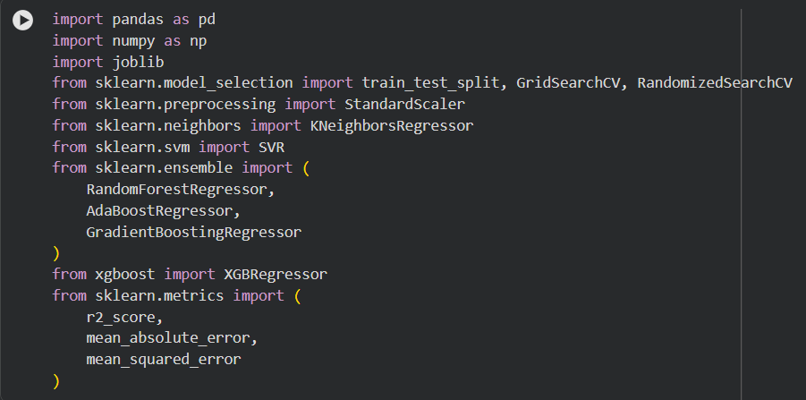

Load Dataset:
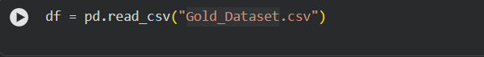

Display First Few Records:
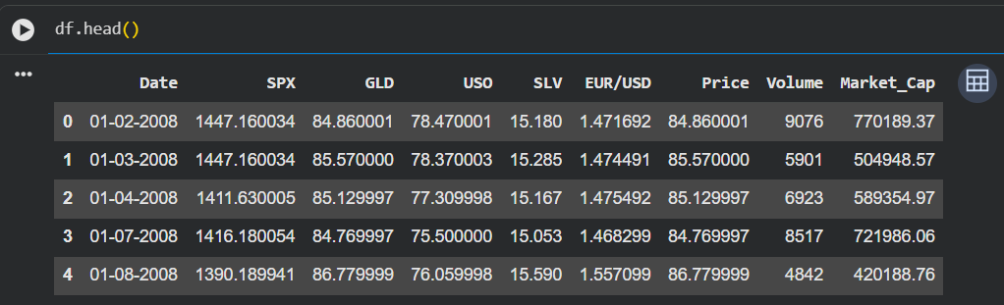

Check Dataset Information:
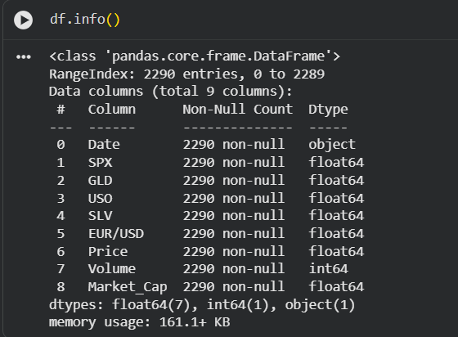

Check Missing Values:
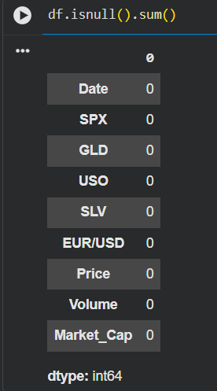

Handle Missing Values:
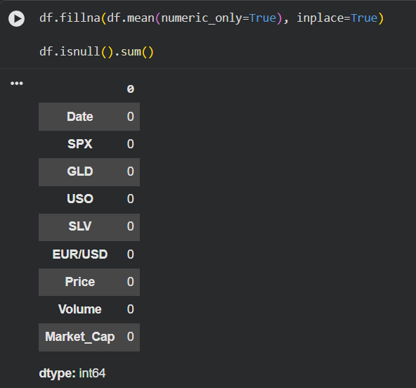

Label Encoding:
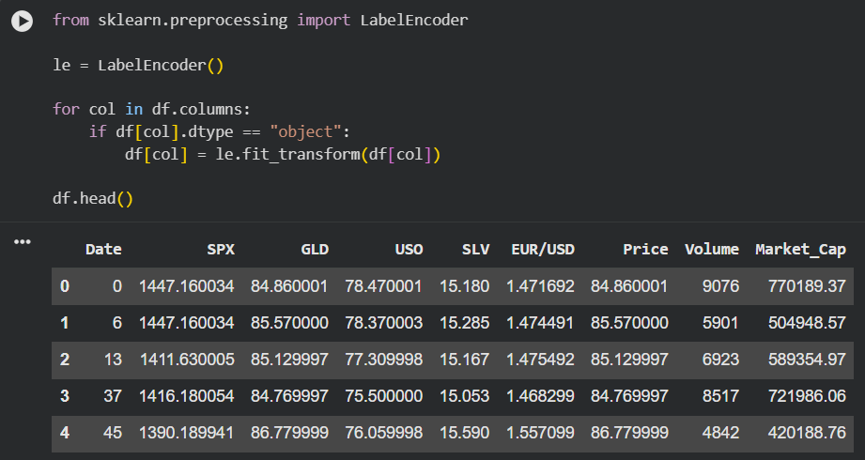

Select Features and Target:

Feature Scaling:
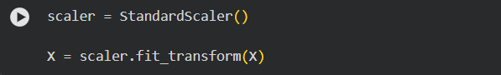

Train-Test Split:
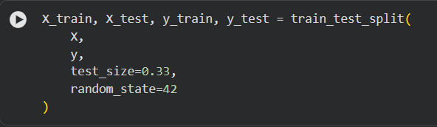
____________________________________________
Q1. Manual Hyperparameter Tuning – KNN Regressor:
Import Library:
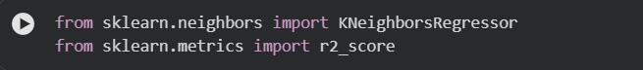

Define K Values:
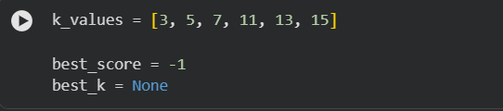

Train Model:
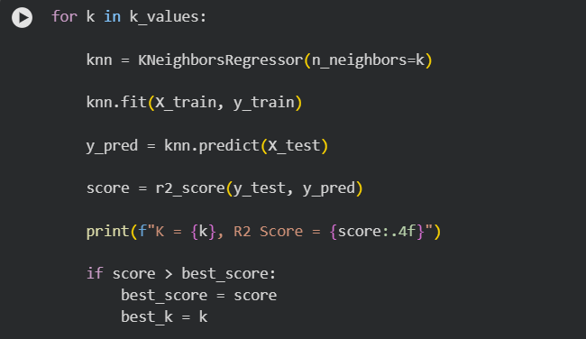
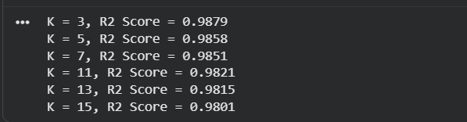

Best Result:
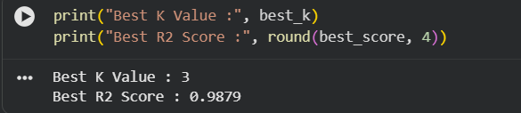
______________________________________________________________________
Q2. Manual Hyperparameter Tuning – SVR:
Import Library:
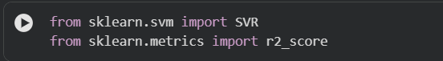

Define Hyperparameters:
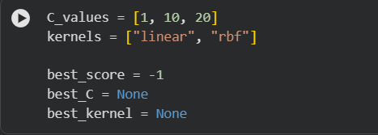

Train Model:
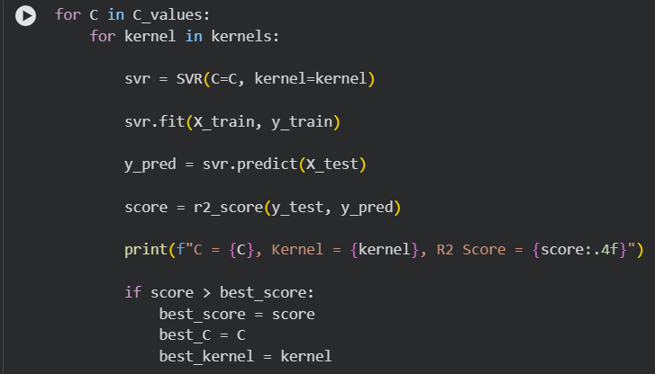
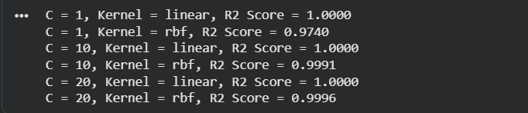

Display Best Result:
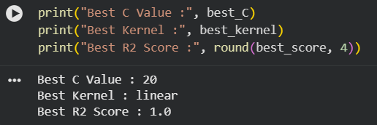

Q5. Grid Search CV:
Import Joblib:

Define Parameter Grid:
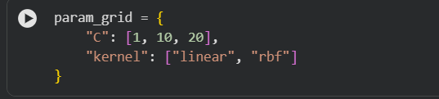

Create GridSearchCV Model:
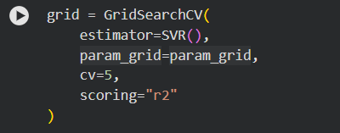

Train Model:
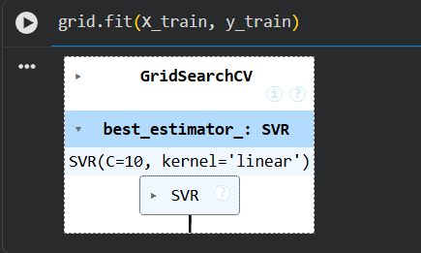

Best Parameters:
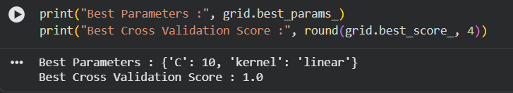

Best Model:
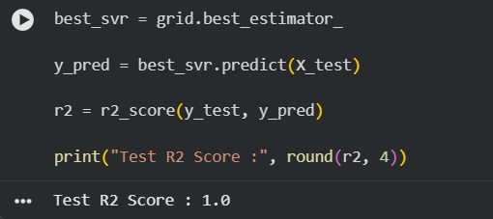
______________________________________________________________________

Q4. Randomized Search CV:
Import Library:

Define Parameter Distribution:
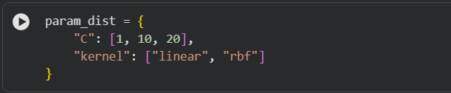

Create RandomizedSearchCV Model:
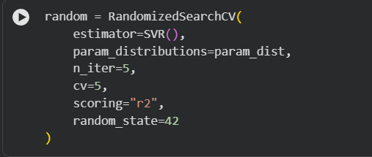

Train Model:
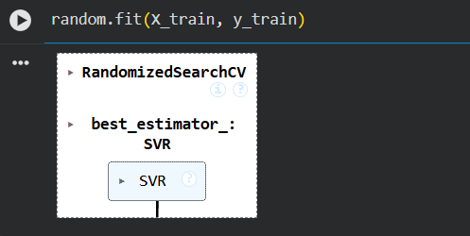

Best Parameters:
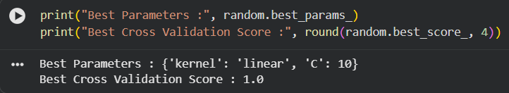

Best Model:
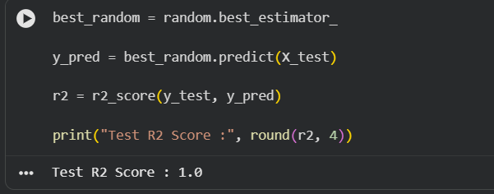
______________________________________________________________________
Q5.Bagging – Random Forest Regressor:
Import Library:
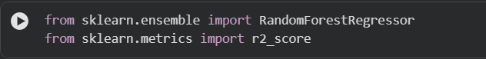

Create Random Forest Model:
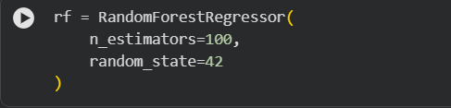

Train the Model:
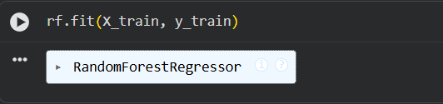

Make Predictions:

Evaluate Model:
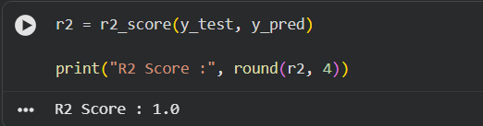
_____________________________________________________________________
Q6. Boosting – AdaBoost & Gradient Boosting:
Import Libraries:

Create Models:
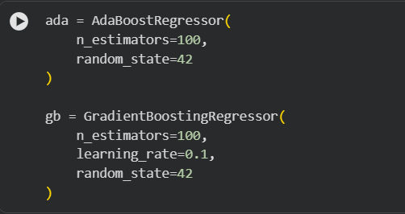

Train Models:
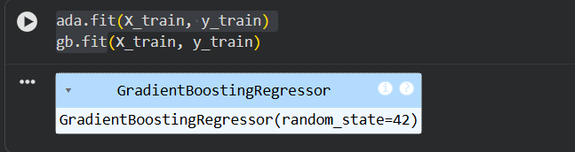

Make Predictions:
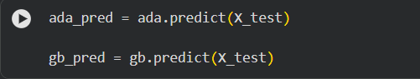

Evaluate Models:
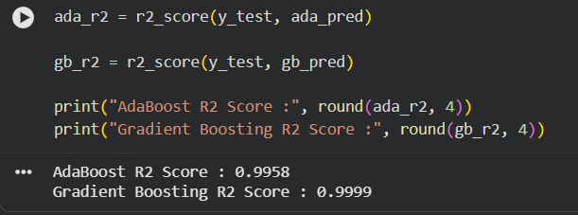
_____________________________________________________________________
Q7. Boosting – XGBoost:
Import Library:
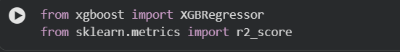

Create XGBoost Model:
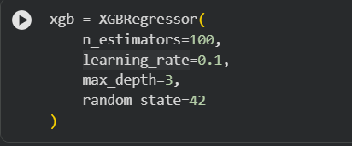

Train the Model:
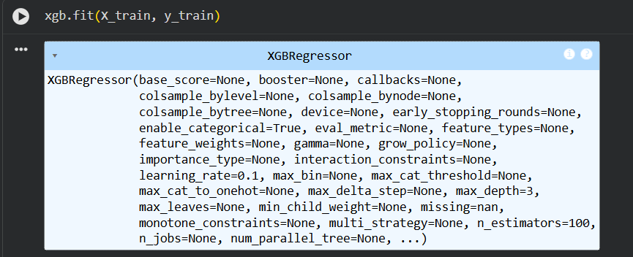

Make Predictions:

Evaluate Model:
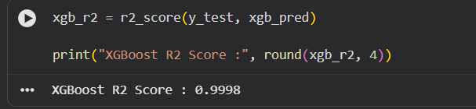

_____________________________________________________________________
Q8. Hyperparameter Tuning on Random Forest:
Import Library:

Define Parameter Grid:
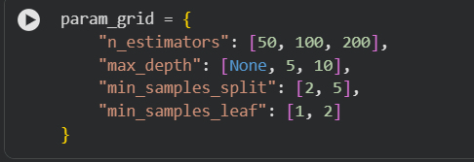

Create GridSearchCV Model:
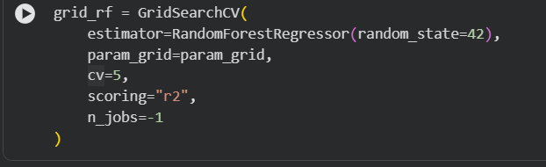

Train the Model:
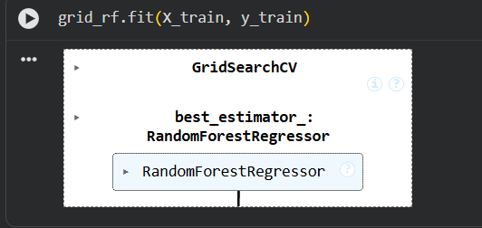

Best Parameters:
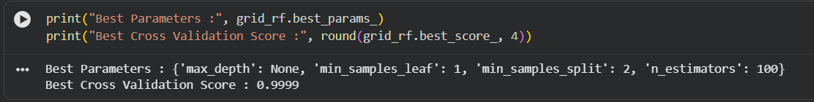

Evaluate Best Model:
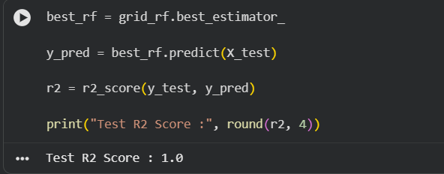
______________________________________________________________________
Q9. Complete Model Comparison:
Make Predictions:
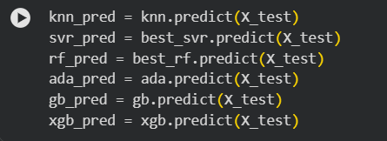

Calculate R² Score:
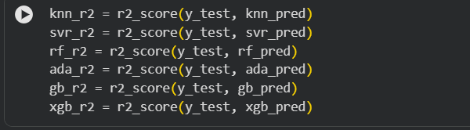

Create Comparison Table:
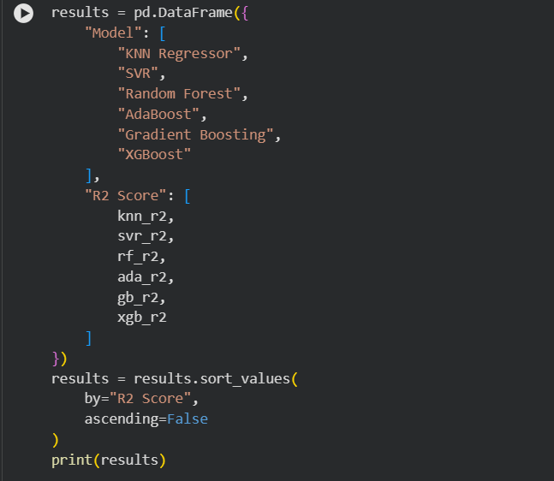
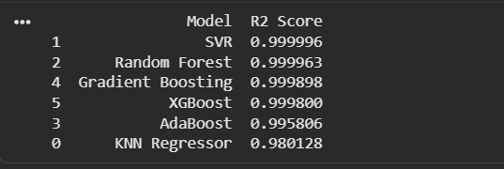

Best Model:
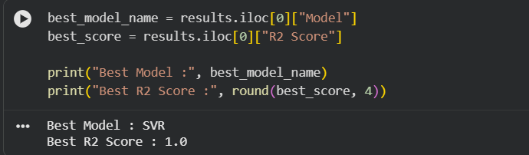
______________________________________________________________________

Q10.Program Code:
import streamlit as st
import pandas as pd
import joblib
model = joblib.load("best_model.pkl")
scaler = joblib.load("scaler.pkl")
st.title("Gold Price Prediction")
st.write("Enter the values to predict Gold Price (GLD)")
spx = st.number_input(
"SPX",
min_value=0.0,
value=1400.0
)
uso = st.number_input(
"USO",
min_value=0.0,
value=35.0
)
slv = st.number_input(
"SLV",
min_value=0.0,
value=30.0
)
eur_usd = st.number_input(
"EUR/USD",
min_value=0.0,
value=1.30
)
if st.button("Predict Gold Price"):

input_data = pd.DataFrame(
[[spx, uso, slv, eur_usd]],
columns=["SPX", "USO", "SLV", "EUR/USD"]
)
input_scaled = scaler.transform(input_data)
prediction = model.predict(input_scaled)
st.success(
f"Predicted Gold Price (GLD): {prediction[0]:.2f}"
)

Output:
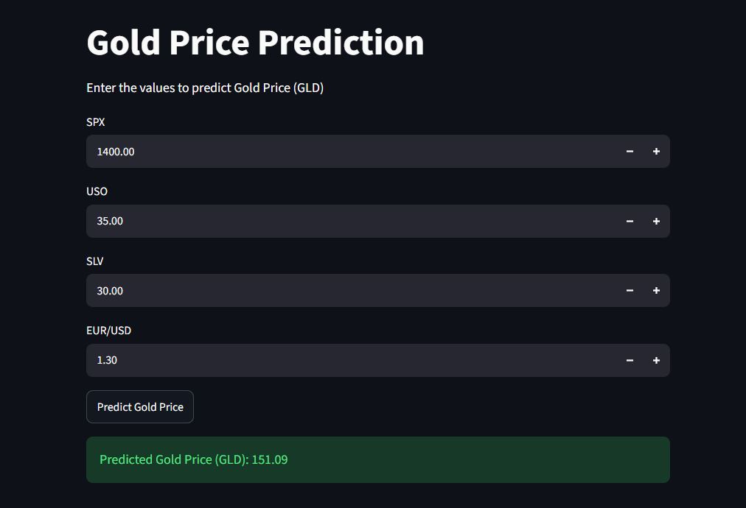
______________________________________________________________________

THANKYOU..!!!

